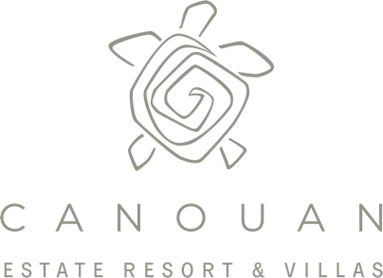

Travel Tips October 2020

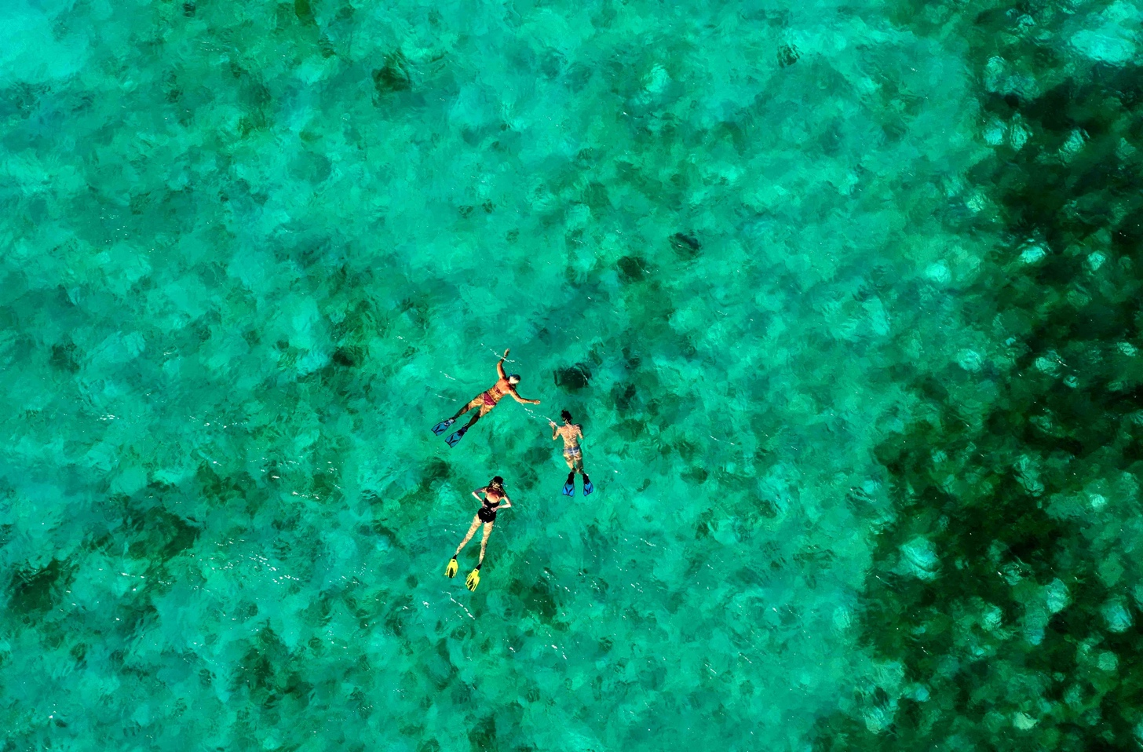

A Resort with a Soul

With our four white sandy beaches and hidden coves and the abundance of nature on the 1200 acre tropical estate, Canouan Estate Resort & Villas is ready to welcome you for a vacation like no other. Our low density private estate consists of only 17 villas and estate homes and 11 suites, promising you ample space and seclusion for you and your loved ones. So get ready to swap that business attire for shorts and flip flops. Our staff full of Vincentian hospitality are ready to welcome you back!

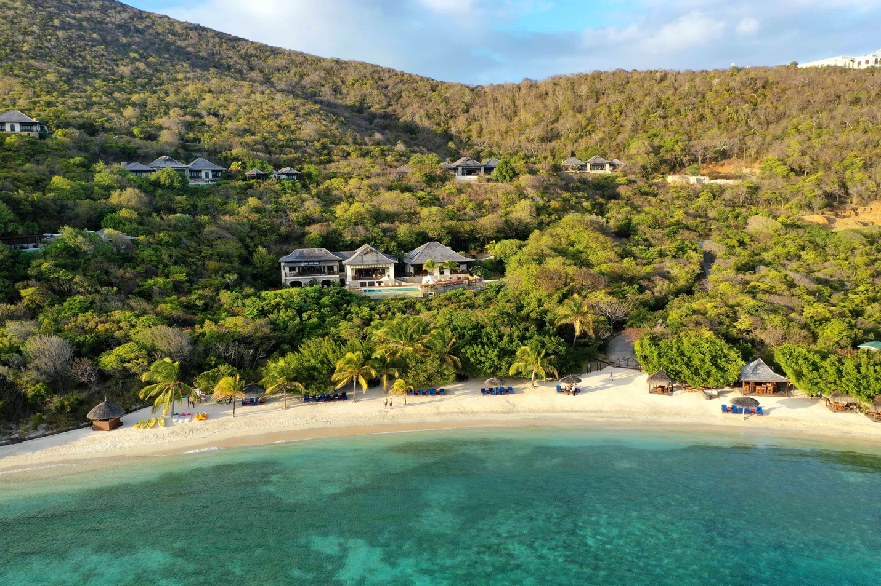

The perfect private villa hideaway for friends and family

Discover our luxury villas and larger estate residences ranging from 2-6 bedrooms on up to 5.6 acres.
Join us for a longer staycation or workaction for more than 2 weeks and enjoy special rates. If you have to work, work from one of luxury retreats with a view.

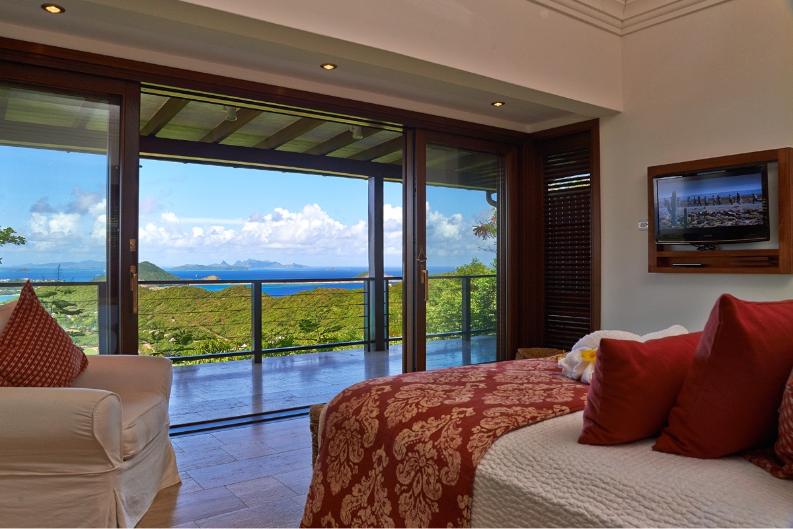

You and your family are our number one priority

Enjoy complete piece of mind when planning your stay at Canouan Estate Resort & Villas, with strict cleaning and sanitation guidelines and protocols implemented across all departments along with physical distancing and personal protective equipment provided for all guests and team members.

For details on the most up to date arrival protocols for St Vincent and the Grenadines please visit:

http://health.gov.vc/health/index.php/covid-19-protocols-documents

Canouan Estate Resort & Villas partners with a number of luxury private jet companies, offering you increased peace of mind for you and your loved ones on your journey here.

Contact us

Canouan Estate Resort & Villas
Carenage Bay
Canouan
St Vincent and the Grenadines
T: +1 784 458 8000 Extn. 4036
Reservations@canouan.com

